

ENA-PROJECT
RESOLINK: DC-DC Wireless Transfer System

Made by :
Muhammad Omais
Ahmed Raziullah
Muhammad Ahsan
Course Instructor:
Prof. Habeel Ahmed

ABSTRACT:
The objective of this project is to design a Portable Wireless Power Bank using rechargeable batteries as its ultimate power, which can be used effectively during travel or a massive power outage. The batteries are connected to a transmitting circuit which itself is connected to a coil whereas the mobile phone is connected to a receiving circuit which is also connected to another coil.

INTRODUCTION :
The major liability or drawbacks of communication lines comes because of the distortion of electrical lines or lack of generation of electricity as like in remote areas or during a disaster or natural calamities. To set back such drawbacks, we need a backup source of energy that can function round the clock without any disruption. Wireless power bank is one of its kind. It works on the power of the pre-charged cells and helps in power transmission which can be used in communication, and thus, turns to be vital during disasters and power outages.

LITERATURE REVIEW:
Late scientist Nikola Tesla was the one who first conceived the idea of Wireless Power Transmission and demonstrated the transmission of electrical energy without wires that depend upon electrical conductivity, as early as 1891. In 1893, Tesla demonstrated the illumination of vacuum bulbs without using wires for power transmission at the World Columbian Exposition in Chicago. In 1904, an airship ship motor of 0.1 horsepower was driven by transmitting power through space from a distance of at least 100 feet. Inductive coupling is used in Oral-B rechargeable toothbrushes by the Braun (Company) since the early 1990s. Research continued in this particular area but very few succeeded. One of the remarkable successes was the Powermat which is our basic motivation for this project. Powermat came with a special case for each mobile phone which acts as the receiver. The main dock, which acts as the transmitter, is connected to the electric socket by a wire. But it was limited to only mobile phones and was not portable. Thus we designed a circuit that will use pre-charged batteries to supply power to any device.

DESIGN:
The project consists of two main circuits
- Transmitter
- Receiver
Transmitter :
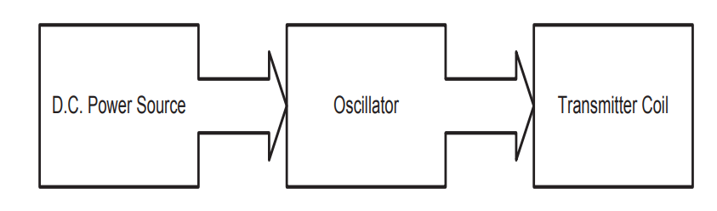
This circuit is comprised of batteries that will provide a DC voltage and an LC tank that converts it into an alternating voltage by constantly switching the transistor on and off. This alternating voltage will produce an alternating current in the coil attached to the transmitter and will induce an e.m.f in the receiver coil.

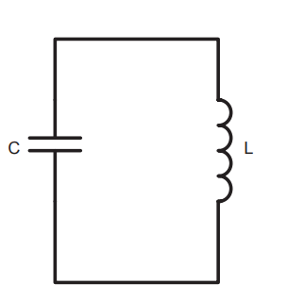
Working Principle of a Simple LC Oscillator: Energy needs to move back and forth from one form to another for an oscillator to work. We can make a very simple oscillator by connecting a capacitor and an inductor. A capacitor stores energy in the form of an electrostatic field, while an inductor uses a magnetic field. If we charge up the capacitor with a battery and then insert the inductor into the circuit, the following will happen: I. The capacitor will start to discharge through the inductor. As it does, the inductor will create a magnetic field. II. Once the capacitor discharges, the inductor will try to keep the current in the circuit moving, so it will charge up the other plate of the capacitor. III. Once the inductor's field collapses, the capacitor has been recharged (but with the opposite polarity), so it discharges again through the inductor. This oscillation will continue until the circuit runs out of energy due to resistance in the wire. It will oscillate at a frequency that depends on the size of the inductor and the capacitor.
Receiver :
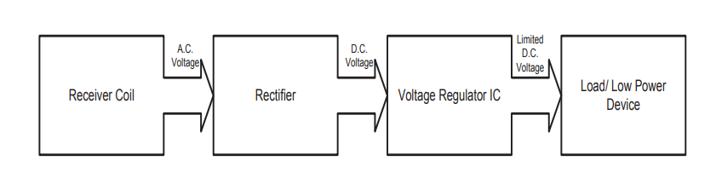
In this part of circuit, the induced voltage is first rectified by the diodes and then this rectified voltage is smoothened by a capacitor. Then this somewhat irregular DC is passed through a voltage regulator which ensures that it does not rise above 5V. Then this 5V is supplied to our required devices.
INDUCTION COILS:
The coils were made from 30 SWG enameled copper wires 6cm diameter and 30 turns each of both , primary and secondary coil.

WORK DETAIL:
Simulations on Multisim:
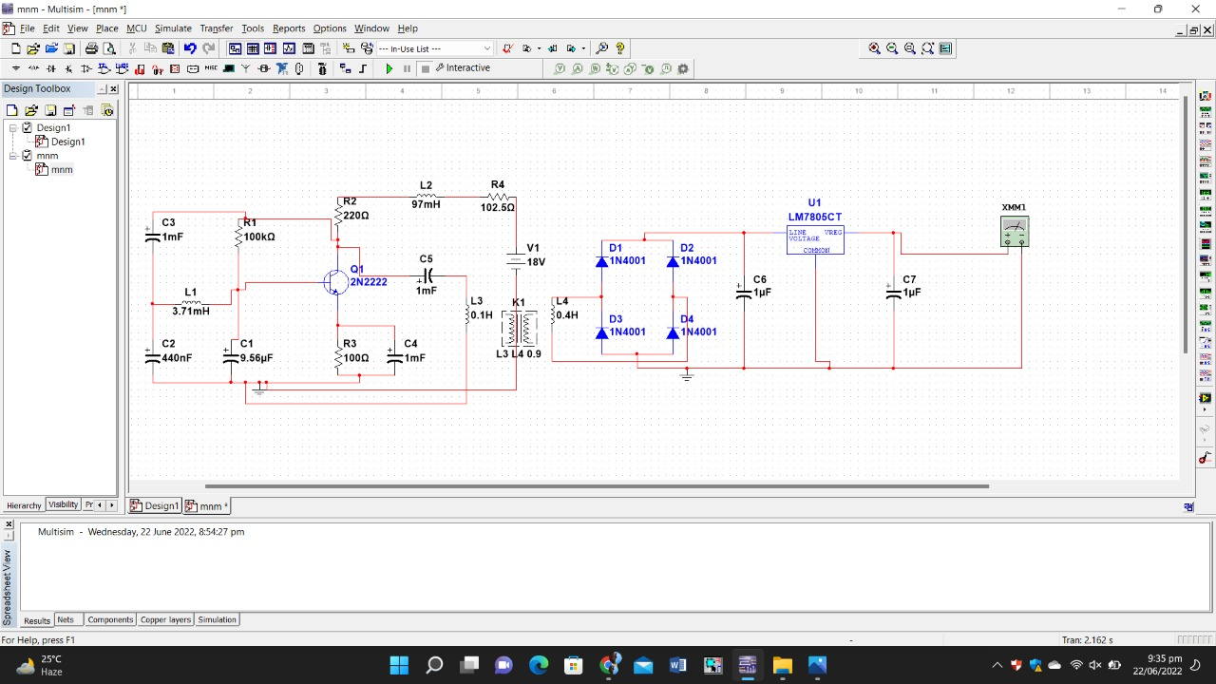

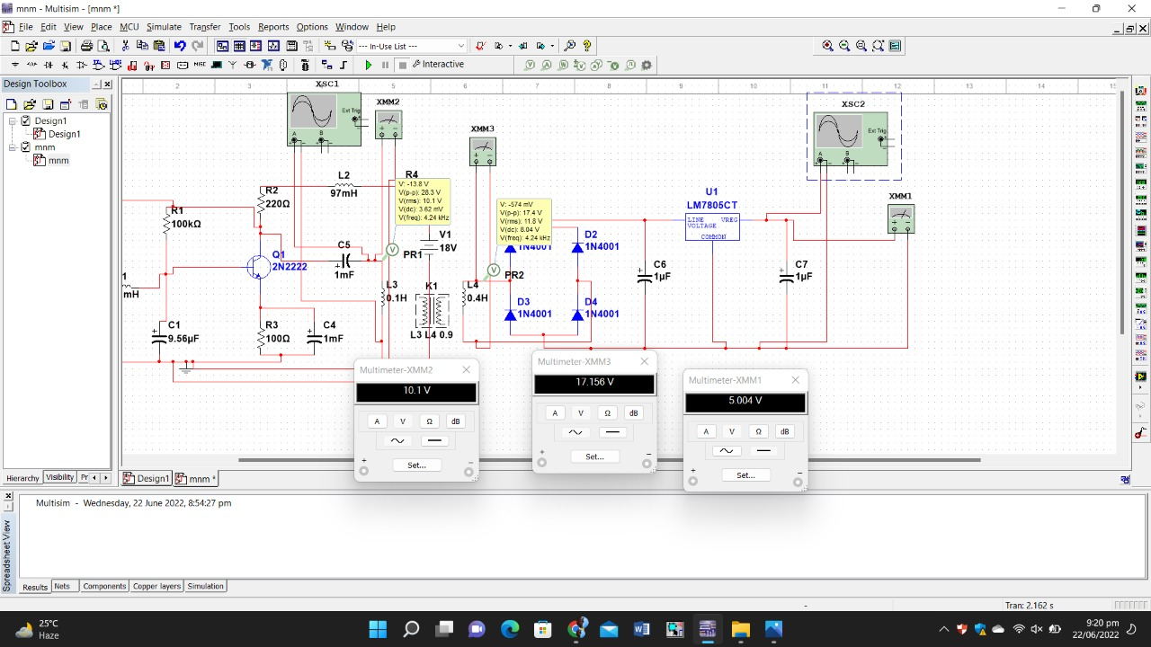The voltage at primary coil is 10.1 Vac and at secondary coil is 17.15 Vac. The voltage at the output after rectification and regulation is 5 Vdc.

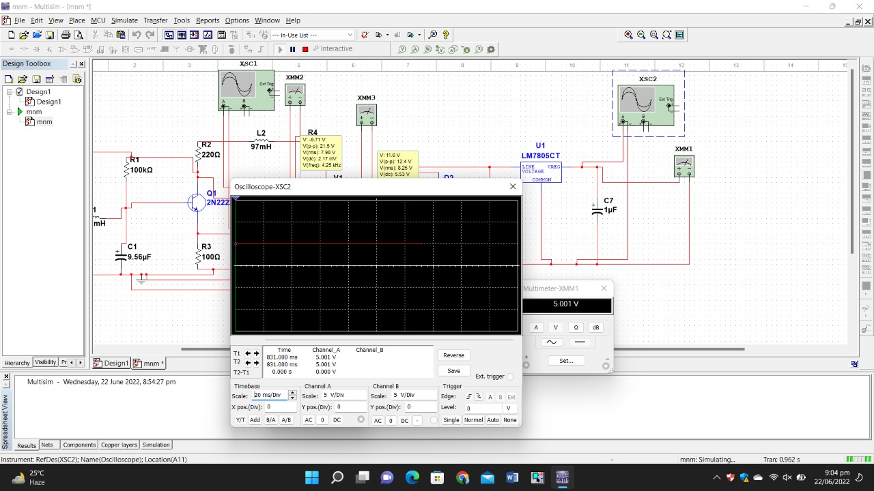

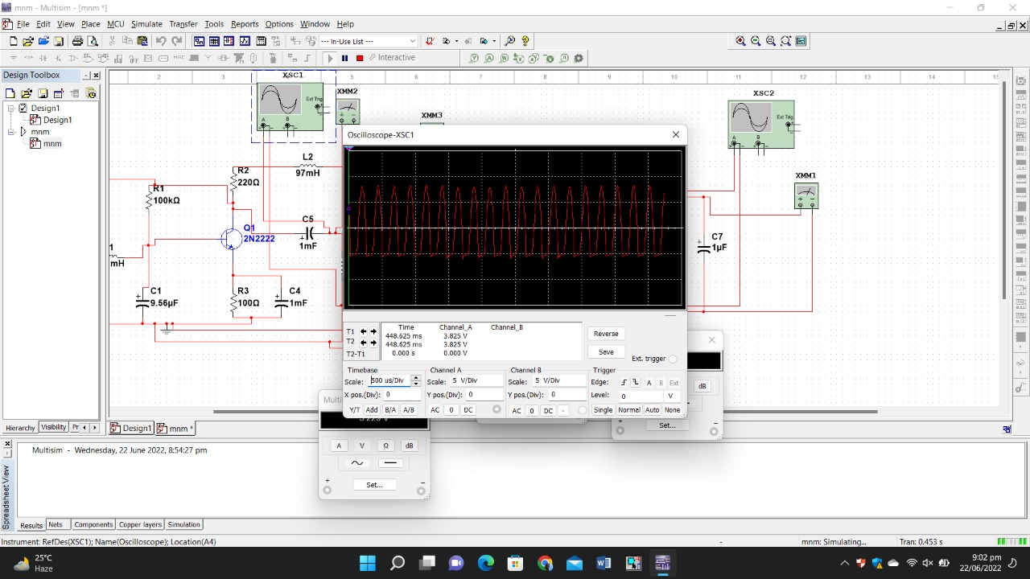
The formula of frequency of oscillator is
$$f=\frac{1}{2π\sqrt{LC}}$$
Where L=3.71 mH , C is series combination of 0.44uF and 9.66uF.

f=4000Hz

OUR WORK:
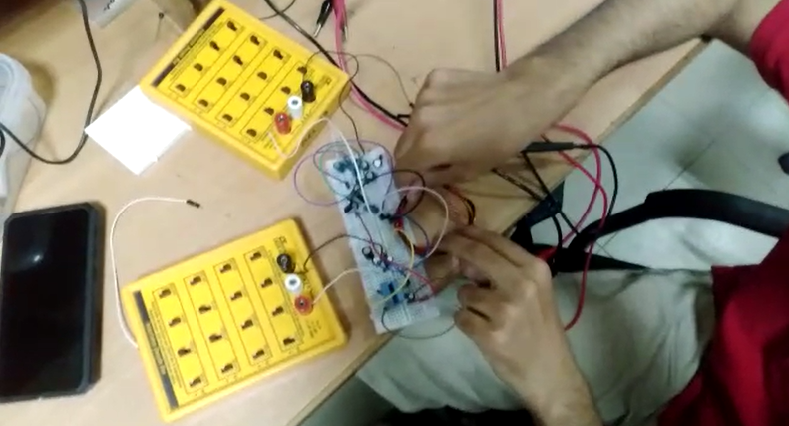

THE OSCILLATOR CIRCUIT

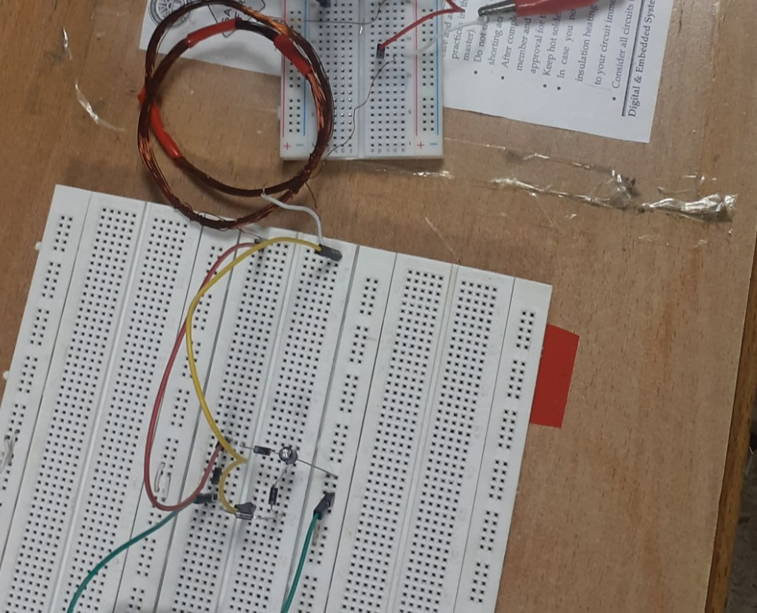
THE RECIEVER CIRCUIT

CONCLUSION:

Oscillators generate continuous periodic waveforms when you apply a specific frequency. LC oscillator, particularly, is a harmonic oscillator or sinusoidal oscillator which generates high-frequency sine waves. Transistor (BJT) acts as a switching device and generates alternating signal at collector end. Inductive power transmission enables the power from an alternating current in one circuit to be coupled from one circuit into another . As wires are not required for the transfer between circuits, inductive power transmission is a wire-less form of technology. Diodes are mainly used for rectification of A.C current for use by many electrical appliances. Rectification is the conversion of sinusoidal waveform into unidirectional (non-zero) waveform. A bridge rectifier is used in full wave rectification. The current flows in the same direction in both half cycles. Basically our model of power bank will supply 5V to any device that is attached to its receiver circuit. But that device cannot move very far away from receiver.

